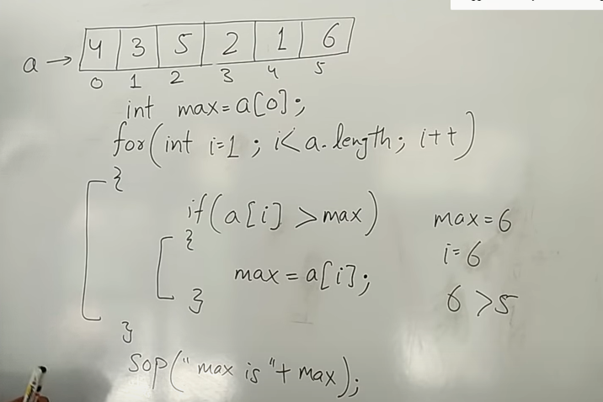

Assume 1st array of value=max to find max and set min to find min

Different types of array sort

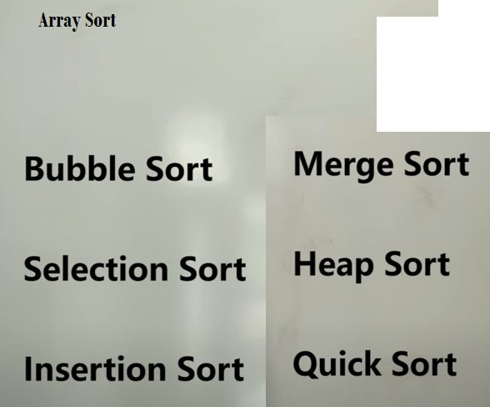



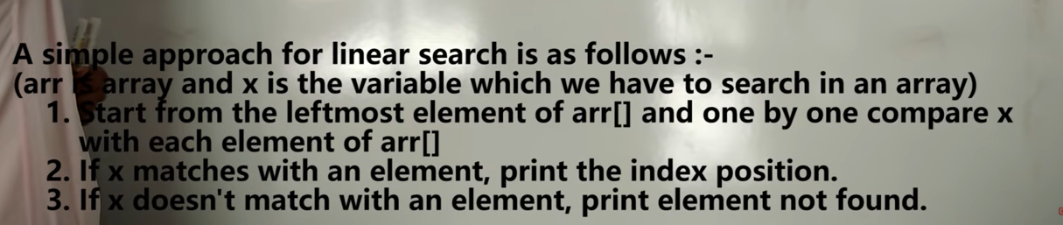

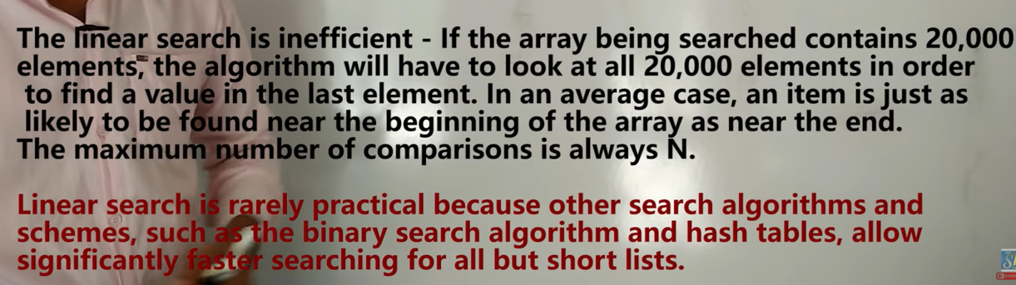

**Bubble sort**

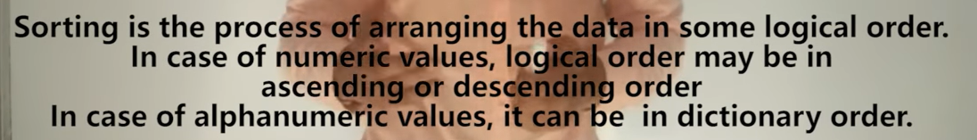

How to find number of rounds

No:of values in thelist-1

If we have 10elements,then rounds=9

If the final adjacent values are correct then no need to compare

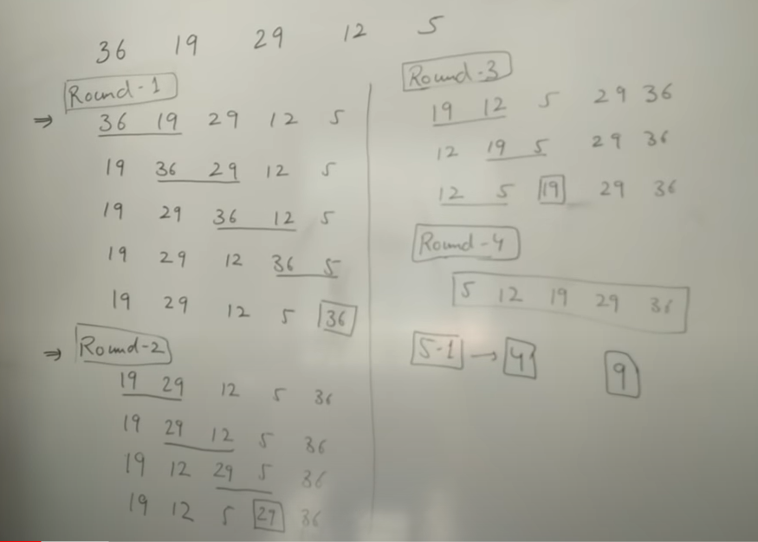

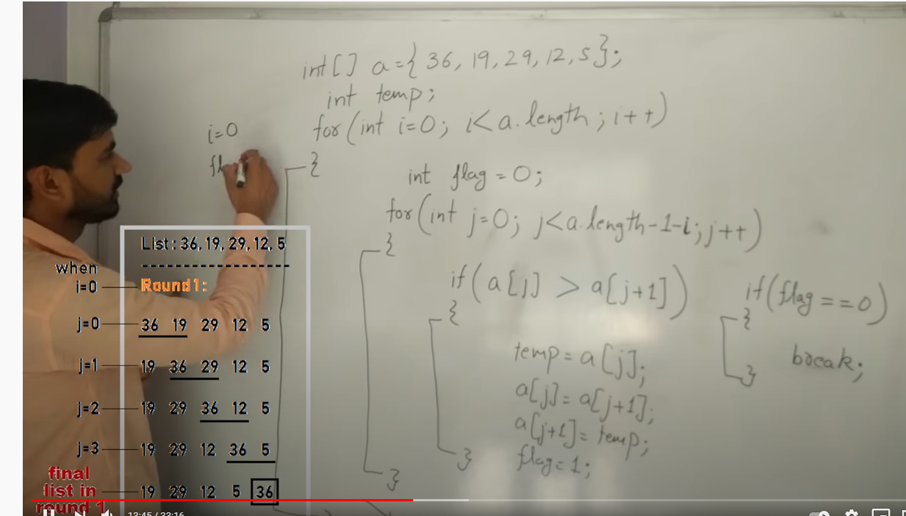

Array Sorting in ascending order

